**A CRM APPLICATION FOR WHOLESALE RICE MILL**

**By**

Valluri.Veera Venkata Satish [2111cs030155@mallareddyuniversity.ac.in](mailto:2111cs030155@mallareddyuniversity.ac.in)

**ProjectAbstract**

Title: Comprehensive CRM Application for Wholesale Rice Mill.

This project involves the development of a comprehensive Customer Relationship Management (CRM) application tailored for a wholesale rice mill using Salesforce. The primary goal was to create an integrated system that enhances operational efficiency, data management, and customer relations within the rice mill factory. The application features custom objects such as Consumers, Rice Mill, Rice Details, and Suppliers, each with its own dedicated tab for streamlined access. A custom Lightning App was designed to unify these components into a cohesive user experience, integrating various objects with relevant fields and page layouts.

Profiles and role hierarchies were meticulously configured to establish clear access levels and permissions, ensuring that different user roles—from owners to workers—have appropriate visibility and control over the data. User accounts were created and assigned profiles, with permission sets used to extend access rights as needed, ensuring tailored access to specific functionalities.

The application’s reporting and dashboard capabilities deliver actionable insights into key metrics such as daily sales volumes, revenue, inventory levels, and customer purchasing patterns. These features facilitate real-time data analysis, aiding in strategic decision-making and operational planning. Custom Apex code was developed to address complex business logic, automate critical workflows, and manage sales transactions and inventory processes efficiently. Validation rules and cross-object formula fields were implemented to ensure data accuracy, with ISBLANK formulas enforcing mandatory field completion. This Salesforce CRM application thus provides a robust and scalable solution for managing the rice mill’s operations, improving operational efficiency, and enhancing customer engagement, while also enabling comprehensive data analysis and reporting for strategic business growth.

Additionally, the integration with external systems for data import and export was set up to facilitate seamless synchronization with existing databases and third-party applications. This ensures that the CRM system operates as a central hub for all business processes, providing a comprehensive view of operations and customer interactions. This Salesforce CRM application thus provides a robust and scalable solution for managing the rice mill’s operations, improving operational efficiency, and enhancing customer engagement, while also enabling comprehensive data analysis and reporting for strategic business growth.

**Keywords:** Salesforce, CRM Application, Custom Objects, Lightning App, Fields, Page Layouts, Profiles, Role Hierarchy, Permission Sets, Reports, Dashboards, Apex, Validation Rules

|  |  |  |
| --- | --- | --- |
|  | **INDEX PAGE** |  |
| Topics |  | Page no. |
| Topic no 1 | Introduction to Salesforce | 04 |
| Topic no 2 | Objects | 06 |
| Topic no 3 | Tabs | 10 |
| Topic no 4 | The Lightning App | 12 |
| Topic no 5 | Fields | 14 |
| Topic no 6 | Page Layouts | 22 |
| Topic no 7 | Proﬁles | 24 |
| Topic no 8 | Role & Role Hierarchy | 28 |
| Topic no 9 | Users | 30 |
| Topic no 10 | Permission Sets | 32 |
| Topic no 11 | Report | 33 |
| Topic no 12 | Dashboards | 37 |
| Topic no 13 | Apex | 39 |

# Task 1: Introduction to Salesforce

## 1.1 Creating Developer Account

Creating a developer org in salesforce.

Go to<https://developer.salesforce.com/signup> On the sign up form, enter the following details :

First name & Last name Email

Role : Developer Company : College Name County : India

Postal Code : pin code

Username : should be a combination of your name and company

This need not be an actual email id, you can give anything in the format

[:username@organization.com](mailto:username@organization.com)

Click on sign me up after filling these.

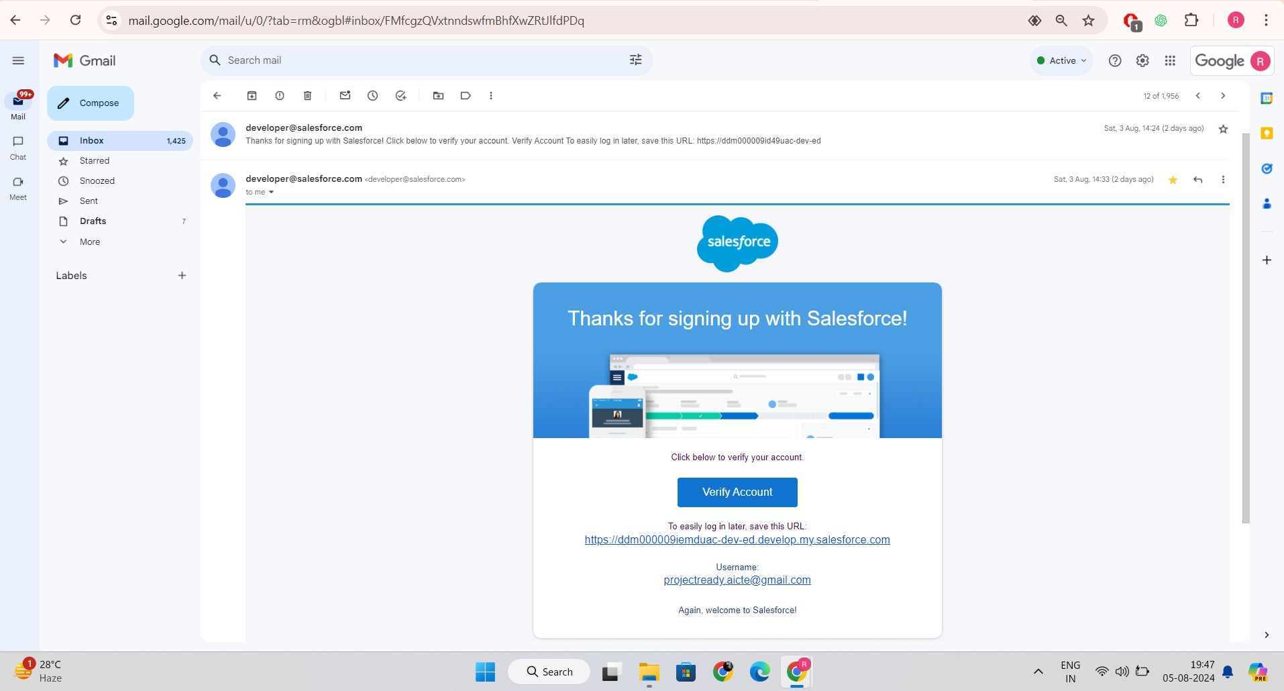–

## Account Activation

Then you will redirect to your salesforce setup page.

# Task 2: Object

Salesforce objects are of two types:

Standard Objects: Standard objects are the kind of objects that are provided by salesforce.com such as users, contracts, reports, dashboards, etc.

Custom Objects:Custom objects are those objects that are created by users. They supply information that is unique and essential to their organization. They are the heart of any application and provide a structure for sharing data.

To Navigate to Setup page:

Click on gear icon -click setup. To create an object:

* + 1. From the setup page - Click on Object Manager -Click on Create - Click on Custom Object.
    2. On Custom object defining page:
    3. Enter the label name, plural label name, click on Allow reports, Allow search.
    4. Click onSave.

## Create Supplier Object

To create an object:

From the setup page >> Click on Object Manager>> Click on Create>>Click on Custom Object.

* + 1. Enter the label name>>supplier
    2. Plural label name>>supplier
    3. Enter Record Name Label and Format
* Record Name >> supplier Name
* Data Type>>Text
  + - 1. Click on Allow reports and Track Field History and allow search
      2. Allow search >> Save.

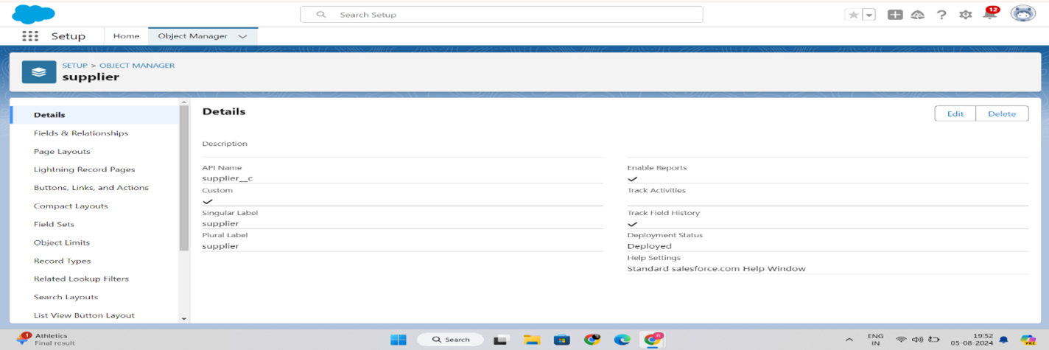

## Create Rice mill Object

To create an object:

From the setup page >> Click on Object Manager>>Click on Create >> Click on Custom Object.

* + 1. Enter the label name>>rice mill
    2. Plural label name>> rice mills
    3. Enter Record Name Label and Format
* Record Name >>
* Data Type >> Auto Number
* Display Format >> rice-{000}
* Starting number >> 1
  + Click on Allow reports and Track Field History, Allow Search and Save.

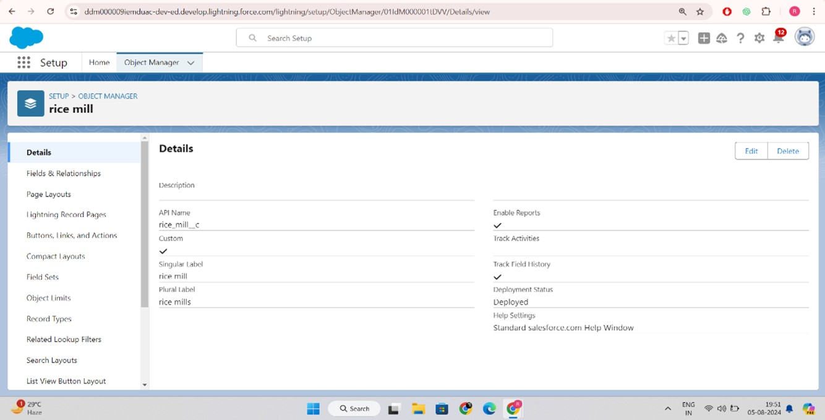

## Create consumer Objects

Note:Follow the same steps as mentioned in Activity 2 for theand Receipt objects.

* + 1. Use these display format for the consumer
* label name >> consumer
* Plural label name >> consumers
* Display Format >> consumers-{000}
* 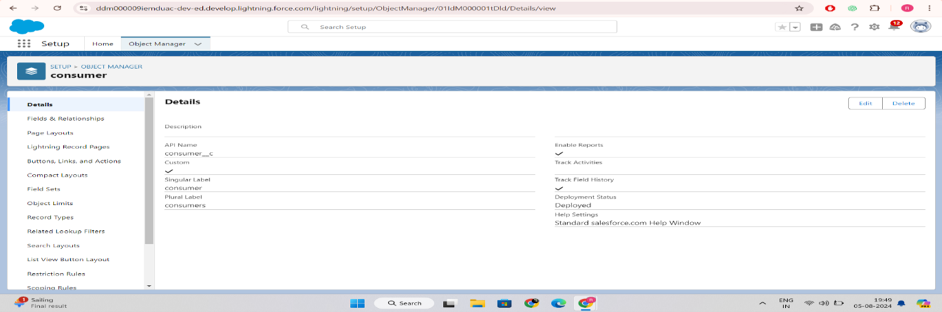Starting number >> 1

## Create rice details Objects

1. Use these display format for the rice details

* label name >> rice details
* Plural label name >> rice details
* Display Format >> rice-{000}
* Starting Number >>1

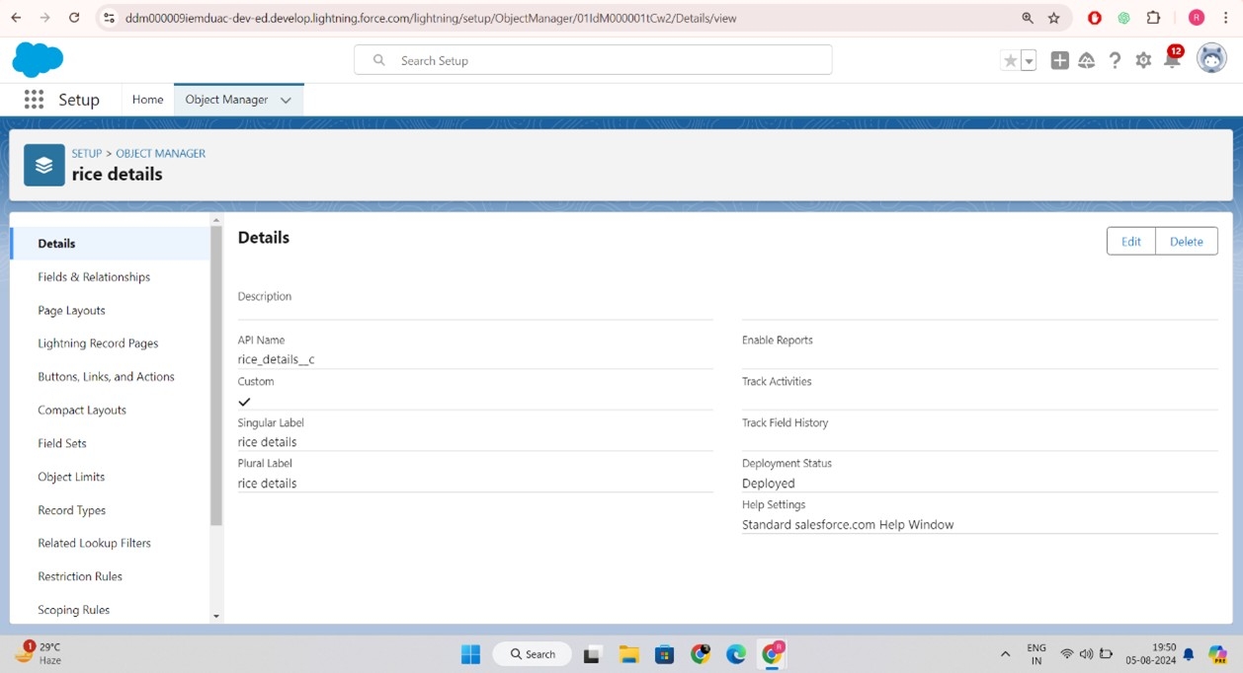

# Task 3 : Tabs

A tab is like a user interface that is used to build records for objects and to view the records inthe objects.

**Types of Tabs:**

**Custom Tabs**

Custom object tabs are the user interface for custom applications that you build in salesforce.com. They look and behave like standard salesforce.com tabs such as accounts, contacts, and opportunities.

**Web Tabs**

Web Tabs are custom tabs that display web content or applications embedded in the salesforce.com window. Web tabs make it easier for your users to quickly access content and applications they frequently use without leaving the salesforce.com application.

**Visualforce Tabs**

Visualforce Tabs are custom tabs that display a Visualforce page. Visualforce tabs look and behave like standard salesforce.com tabs such as accounts, contacts, and opportunities.

**Lightning Component Tabs**

Lightning Component tabs allow you to add Lightning components to the navigation menu in Lightning Experience and the mobile app.

**Lightning Page Tabs**

Lightning Page Tabs let you add Lightning Pages to the mobile app navigation menu.

Lightning Page tabs don't work like other custom tabs. Once created, they don't show up on the All Tabs page when you click the Plus icon that appears to the right of your current tabs. Lightning Page tabs also don't show up in the Available Tabs list when you customize the tabs for your apps.

## Creating a Custom Tab

* + - To create a Tab:(supplier)
    - Go to setup page >> type Tabs in Quick Find bar >> click on tabs >> New (under custom object tab)
    - Select Object(supplier) >> Select the tab style >> Next (Add to profiles page) keep it as

default >> Next (Add to Custom App) uncheck the include tab .

* + - Make sure that the Append tab to users' existing personal customizations is checked.
    - 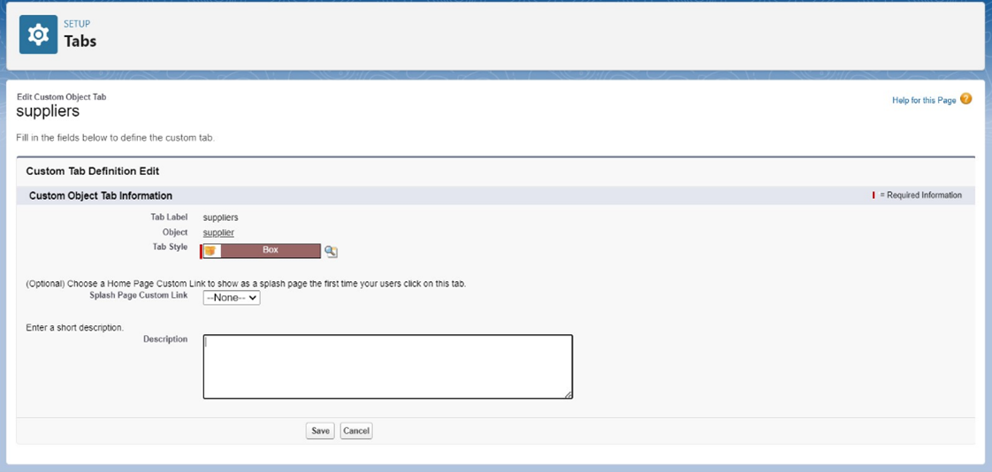Click save.

## Creating Remaining Tabs

1. Now create the Tabs for the remaining Objects, they are “ rice mill,consumer, rice details”.
2. Follow the same steps as mentioned in Activity -1 .

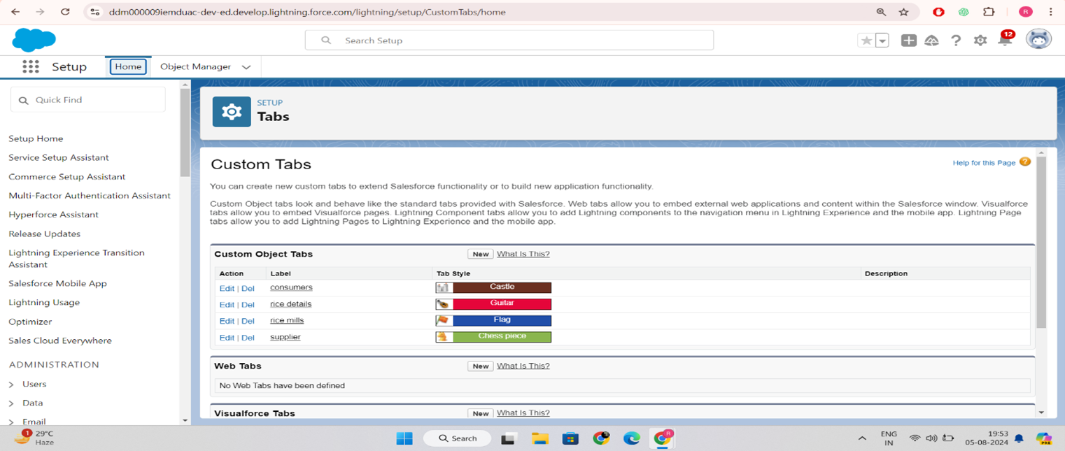

# Task 4 : The Lightning App

An app is a collection of items that work together to serve a particular function. In Lightning Experience, Lightning apps give your users access to sets of objects, tabs, and other items all in one convenient bundle in the navigation bar.

Lightning apps let you brand your apps with a custom color and logo. You can even include a utility bar and Lightning page tabs in your Lightning app. Members of your org can work more efficiently by easily switching between apps.

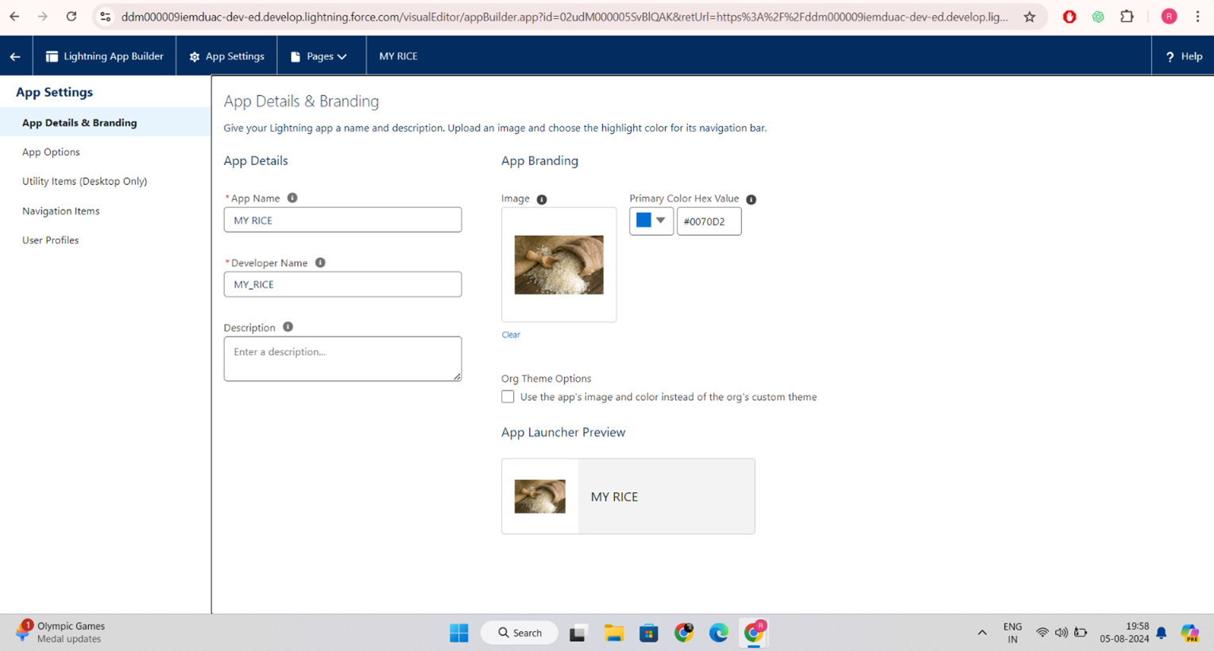

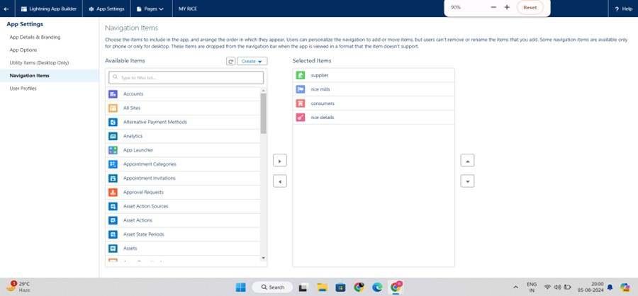

# Task 5 : Fields

When we talk about Salesforce, Fields represent the data stored in the columns of a relational database. It can also hold any valuable information that you require for a specific object. Hence, the overall searching, deletion, and editing of the records become simpler and quicker.

### Types of Fields

1. Standard Fields
2. Custom Fields

### Standard Fields:

As the name suggests, the Standard Fields are the predefined fields in Salesforce that perform astandard task. The main point is that you can’t simply delete a Standard Field until it is anon- required standard field. Otherwise, users have the option to delete them at any point fromthe application freely. Moreover, we have some fields that you will find common in everySalesforce application. They are,

1. Created By
2. Owner
3. Last Modified
4. Field Made During object Creation

### Custom Fields:

On the other side of the coin, Custom Fields are highly flexible, and users can change themaccording to requirements. Moreover, each organizer or company can use them if necessary. Itmeans you need not always include them in the records, unlike Standard fields. Hence, the finaldecision depends on the user, and he can add/remove Custom Fields of any given form**.**

* 1. **Creating the number field in rice details object**

Creating the number field in rice details object

* + 1. Go to the setup page >> click on object manager >> From drop down click edit for rice details object
    2. Click on fields & relationship >> click on New.
    3. Select Data type as “Number” and click Next.
    4. Given the Field Label as “ rice distributed ” and length as “ 5 ”.
    5. 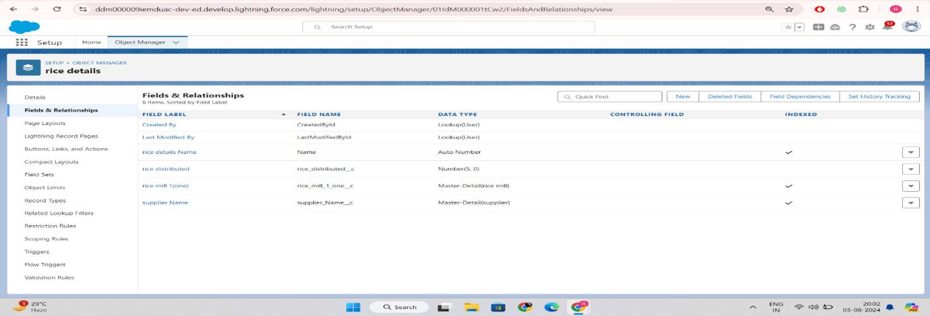Field Name will be auto populated, and click on Next- Next >> Save.

## Creating Junction Object

A Junction object is a custom object that serves as a bridge between two related objects in a many-to-many relationship. It allows you to create a relationship between records of two

different objects by creating a many-to-many relationship model.

Creating junction object as rice details withsupplier& rice mill To create junction object

Go to the setup page >> click on object manager >> From drop down click edit for rice details object

Click on fields & relationship - click on New.

Select “Master-Detail relationship” as data type and click Next.

* + 1. Select the related object “ supplier ” and click next.
    2. Give Field Label as “supplier Name” and click Next.
    3. Next >> Next >> Save & New.
    4. Follow the same steps from 1 to 3.
    5. Select the related object “ rice mill ” and click Next.
    6. Give Field Label as “rice mill 1(one)” and click Next.
    7. Next >> Next >> Save.

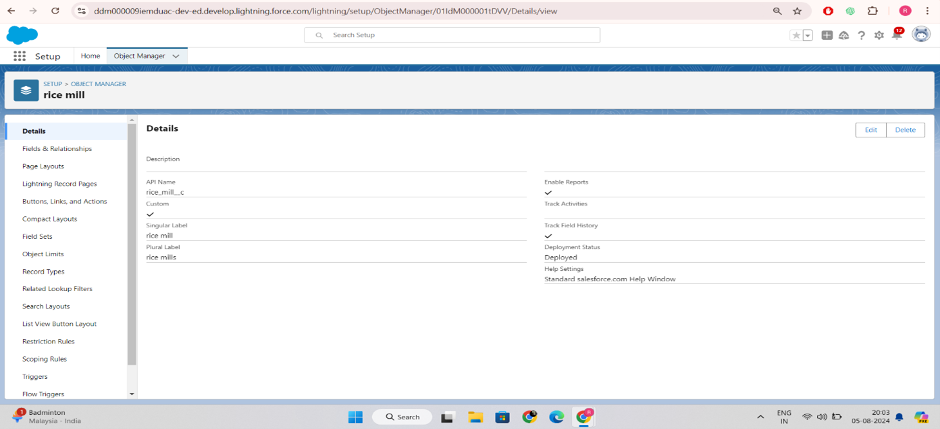

## Creating a Master-Detail Relationship

master-detail relationship is a type of relationship between two objects where the master object controls certain behaviors and settings of the detail object. Here are a few use cases that demonstrate the use of master-detail relationships

Creating Master-Detail Relationship between consumer& rice mill Object To Create a Master-Detail relationship

* + 1. Go to the setup page >> click on object manager >> From drop down click edit for consumer object.
    2. Click on fields & relationship >> click on New.
    3. Select “Master-Detail relationship” as data type and click Next.
    4. Select the related object “ rice mill”.
    5. Give Field Label as “rice mill name” and click Next.
    6. Next >> Next >> Save.

## Creating the Roll-up summary field on supplier & rice mill Objects.

* + 1. Go to setup >> click on Object Manager >> type object name(supplier) in search bar

>> click on the object.

* + 1. Now click on “Fields & Relationships” >> New
    2. Select the data type as “Rollup summary ”,and click Next.
    3. Give the Field label as “ sum of rice distributed ”,Field Name will be Auto generated, and click Next.

Select the summarized object as “ rice details ”.

* + 1. Select the Rollup type as “sum”.
    2. Select the field to aggregate as “ rice distributed ”, and click Next >>Next >>Save.
    3. Follow the same steps for the rice mill Object from 1 to 3
    4. Give the Field label as “ rice distributed to shops ”,Field Name will be Auto generated, and click Next.
    5. Select the summarized object as “ rice details ”.
    6. Select the Rollup type as “sum”.
    7. Select the field to aggregate as “ rice distributed ”, and click Next >> Next >> Save.
    8. Note :create the field as “ rice taken by shops in kgs” using number datatype in consumer object
    9. Follow the same steps for the rice mill Object from 1 to 3
    10. Give the Field label as “ rice taken ”,Field Name will be Auto generated, and click Next.
    11. Select the summarized object as “ consumer”.
    12. Select the Rollup type as “sum”.
    13. Select the field to aggregate as “ rice taken in shops ”, and click Next >> Next >> Save.

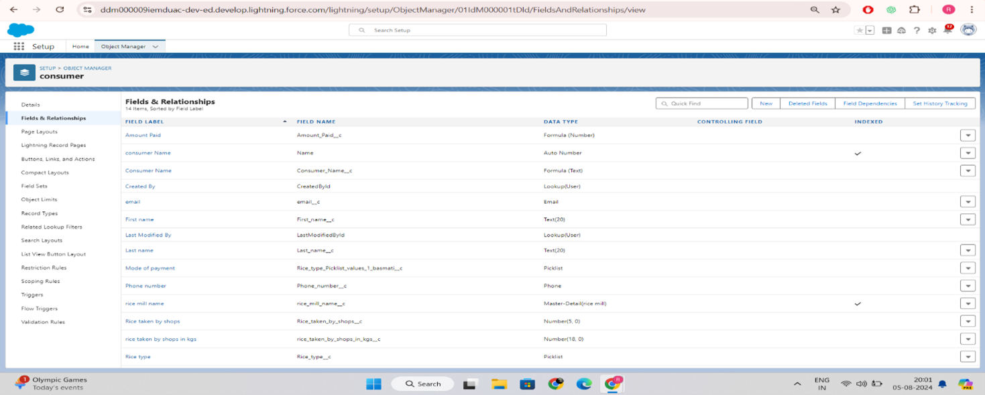

## Creating the number field in rice details object

* + 1. Go to the setup page >> click on object manager >> From drop down click edit for rice details object.
    2. Click on fields & relationship >> click on New.
    3. Select Data type as “master detail” and click Next.
    4. Given the Field Label as “ supplier name ” and length as “ 5
    5. Field Name will be auto populated, and click on Next>> Next >>Save.

## Creating Fields in rice mill Objects

* + 1. Select Data type as “Number” and click Next.
    2. Given the Field Label as “ rice price/kg ” and length as “ 5 ”

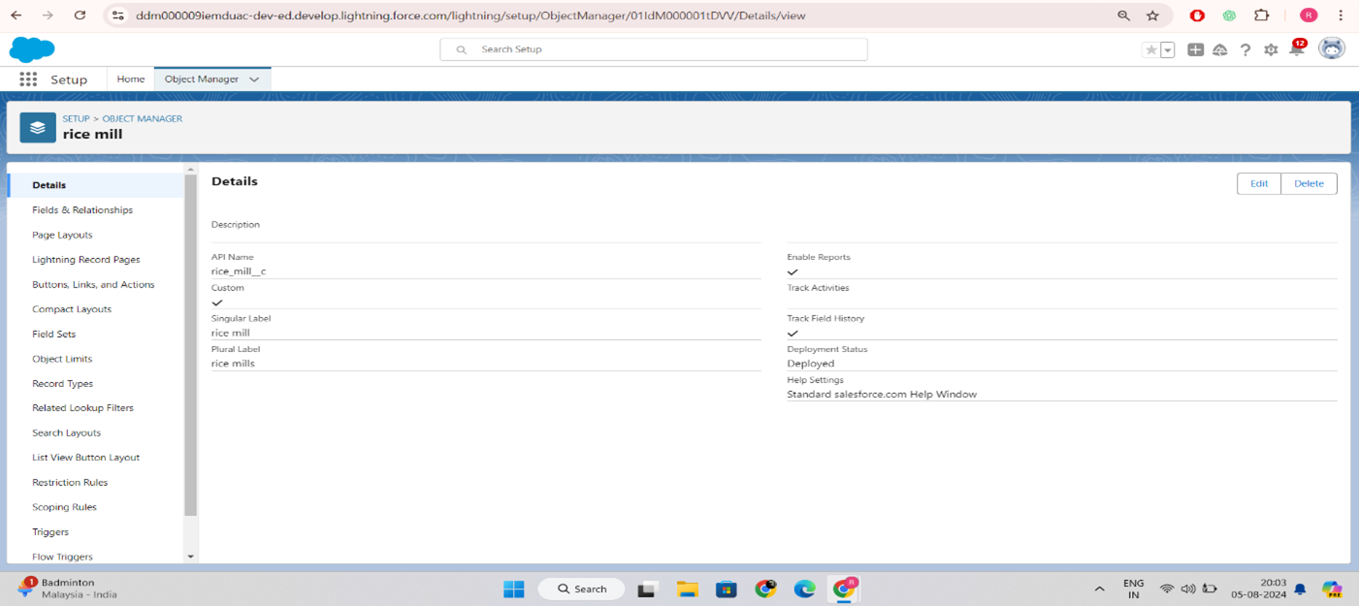

## Creating Fields in consumer Objects

* 1. **Creating Cross Object Formula Field in consumer Object**

A cross-object formula field is a formula field that references fields from another object in Salesforce. This type of formula allows users to calculate and display data from multiple objects on

a single record.

Note :check whether the fields mentioned in the formula field are created or not , if not go to activity 9 and create those fields mentioned in consumer object.

* + 1. Go to setup >> click on Object Manager >> type object name(consumer) in search bar

>> click on the object.

* + 1. Click on fields & relationship >> click on New.
    2. Select Data type as “Formula” and click Next.
    3. Give Field Label and Field Name as “Amount Paid ” and select formula return type as “Number” and click next.
    4. Insert fields formula should be :

rice_taken_by_shops c * rice_mill_name r.rice_price_kg c

* + 1. 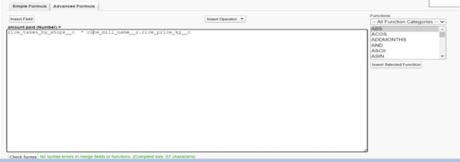Under Advanced Formula write down the formula and click “Check Syntax” and Save.

## Creating the validation rule

Improve the quality of your data using validation rules. Validation rules verify that the data a user enters in a record meets the standards you specify before the user can save the record. A validation rule can contain a formula or expression that evaluates the data in one or more fields and returns a value of “True” or “False”. Validation rules also include an error message to display to the user when the rule returns a value of “True” due to an invalid value.

Creating the validation rule for phone number field in consumer object

Note :check whether the fields mentioned in the formula field are created or not , if not go to activity 9 and create those fields mentioned in consumer object.

Go to the setup page >>click on object manager >> From drop down click edit for consumer object.

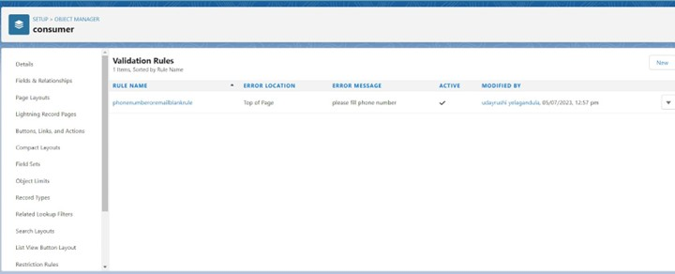Click on the validation rule >> click New.

* + 1. Enter the Rule name as “Phonenumberoremailblankrule
    2. Enter the description as “phone number and email number should not be blank”
    3. Enter the formula as “OR( ISBLANK( phone_number c ) , ISBLANK( email c )

)” and check the syntax.

* + 1. Under the error message write as”please fill in your phone number.”
    2. Select error location “top of page”.
    3. Save the validation rule.

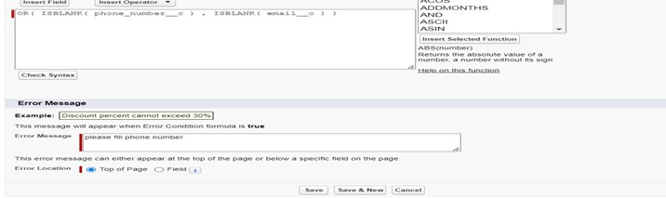

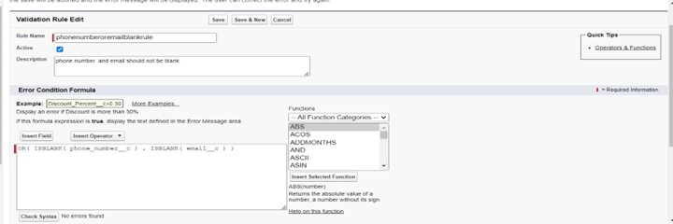

# Task 6 : Page Layouts

Page Layout in Salesforceallows us to customize the design and organize detail and edit pages of records in Salesforce. Page layouts can be used to control the appearance of fields, related lists, and custom links on standard and custom objects' detail and edit pages.

## creating the page layout

* + 1. To Create a Page layout:
    2. Go to Setup >> Click on Object Manager >>Search for the object (consumer) >> From drop down select the object and click on it.
    3. Click on Page layout >> Click on New.
    4. Select the existing page layout, and give the page layout name as “consumer layout”, and

click save.

* + 1. Drag and drop the section field to consumer details and create the section.
    2. Enter the section name as “Personal details”, - click Ok.
    3. Now drag the fields to this section that mentioned , they are
    4. First name , last name , consumer name , phone number, email, rice mill name.
    5. Follow the same process for another two sections as shown above , they are
    6. One section is “ rice details ” , drag the fields that are
    7. Rice taken by shop, rice type.
    8. Another section is “Receipt details ”, and drag the fields that are
    9. Mode of payment , Amount paid. 14.Then , Click save.

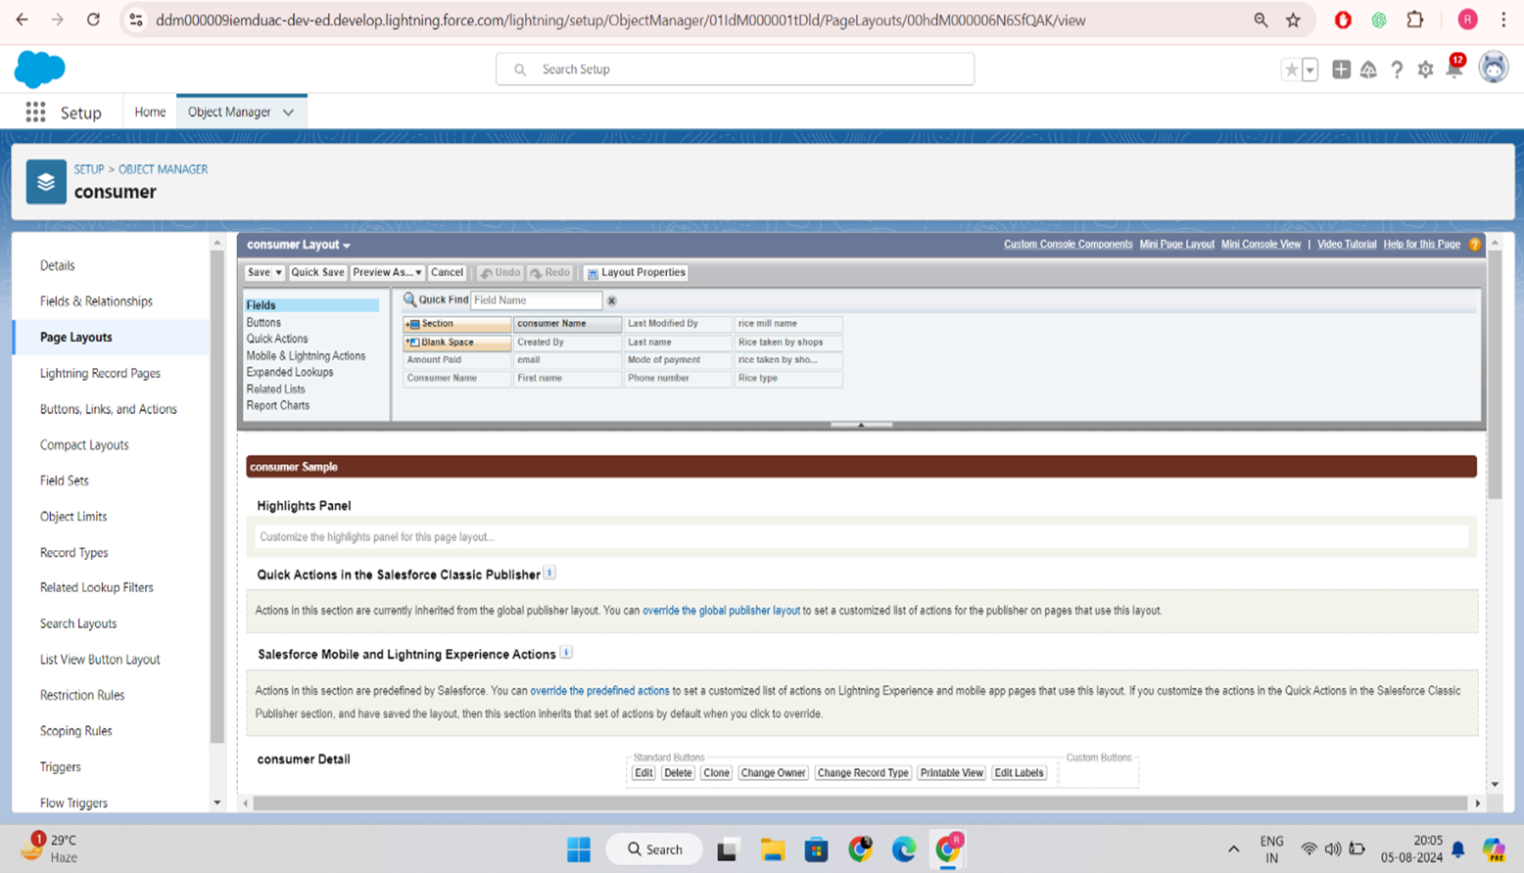

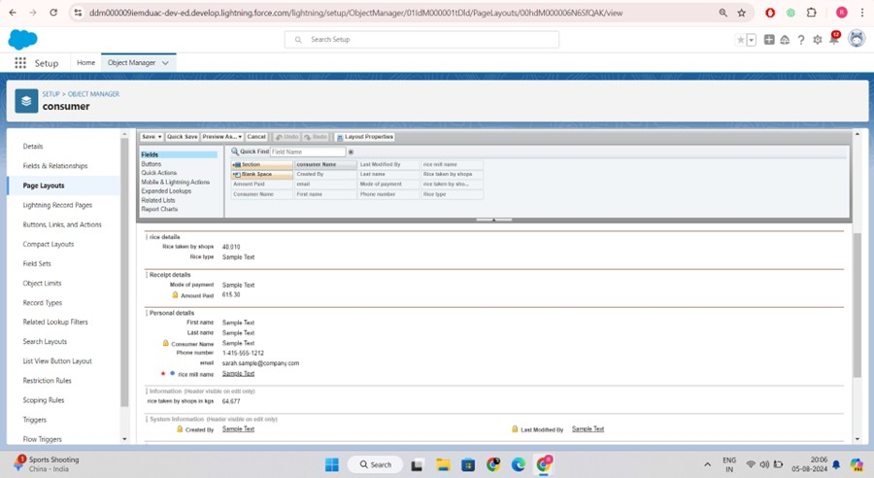

# Task 7 : Profiles

profile is a group/collection of settings and permissions that define what a user can do in salesforce.Profile controls “Object permissions, Field permissions, User permissions, Tab settings,App settings, Apex class access, Visualforce page access, Page layouts, Record Types,Login hours & Login IP ranges.You can define profiles by the user's job function. For example System Administrator,Developer, Sales Representative.

### Types of profiles in salesforce

1. Standard profiles:

By default salesforce provides below standard profiles.

* Contract Manager
* Read Only
* Marketing User
* Solutions Manager
* Standard User
* System Administrator. We cannot deleted standard ones

Each of these standard ones includes a default set of permissions for all of the standard objects available on the platform.

1. Custom Profiles:

Custom ones defined by us.

They can be deleted if there are no users assigned with that particular one

* 1. **owner Profile**

To create a new profile:

Go to setup >> type profiles in quick find box >> click on profiles >> clone the desired profile (Standard User) >>enter profile name (owner) >> Save.

Scroll down to Custom Object Permissions and Give access permissions for consumers, rice details , rice mill and suppliers objects as mentioned in the below diagram.

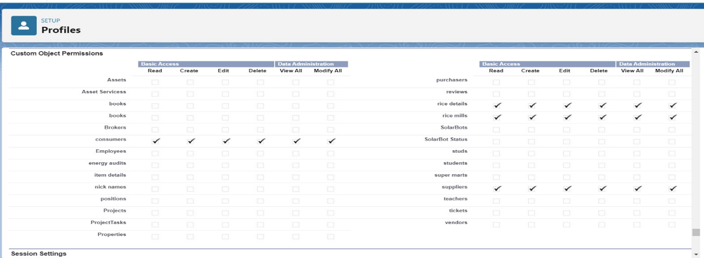

Give access and save it.

## employer Profile

* + 1. Go to setup >> type profiles in quick find box >>click on profiles >> clone the desired profile (Standard Platform User) >> enter profile name (employer) >> Save.
    2. While still on the profile page, then click Edit.
    3. Select the Custom App settings as default for the rice mill.
    4. Scroll down to Custom Object Permissions and Give access permissions for consumer, rice details , rice mill and suppliers objects as mentioned in the below diagram.

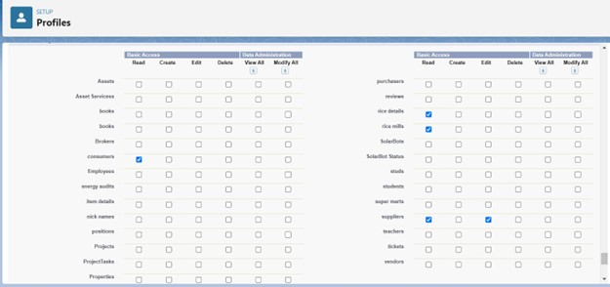

1. And click save.

## worker Profile

* + 1. Go to setup >> type profiles in quick find box >> click on profiles >> clone the desired profile (Standard Platform User) >> enter profile name (worker) >> Save.
    2. While still on the profile page, then click Edit.
    3. Select the Custom App settings as default for the rice mill.
    4. Scroll down to Custom Object Permissions and Give access permissions for consumer, rice details , rice mill and suppliers objects as mentioned in the below diagram.

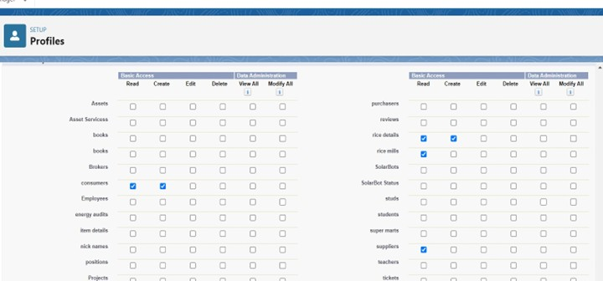

1. And click save.

# Task 8 : Role & Role Hierarchy

A role in Salesforce defines a user's visibility access at the record level. Roles may be used to specify the types of access that people in your Salesforce organization can have to data. Simply put, it describes what a user could see within the Salesforce organization.

## Creating owner Role

* + 1. Creating owner Role:
    2. Go to quick find >> Search for Roles >> click on set up roles.
    3. Go to quick find >> Search for Roles >> click on set up roles.
    4. Click on Expand All and click on add role under whom this role works.
    5. 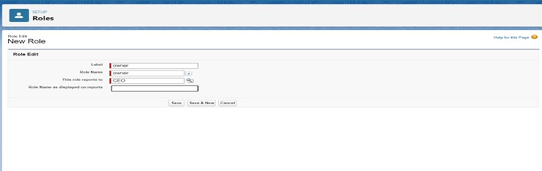Give Label as “owner” and Role name gets auto populated. Then click on Save.

## Creating employer roles

* + 1. Creating another two roles under manager
    2. Go to quick find >>Search for Roles >>click on set up roles.
    3. Click plus on CEO role, and click add role under owner.
    4. Give Label as “employer” and Role name gets auto populated. Then click on Save.
    5. Repeat the same steps, for another role.
    6. Click plus on CEO role, and click plus on owner, and click add role under employer.
    7. ive Label as “worker” and Role name gets auto populated. Then click on Save.

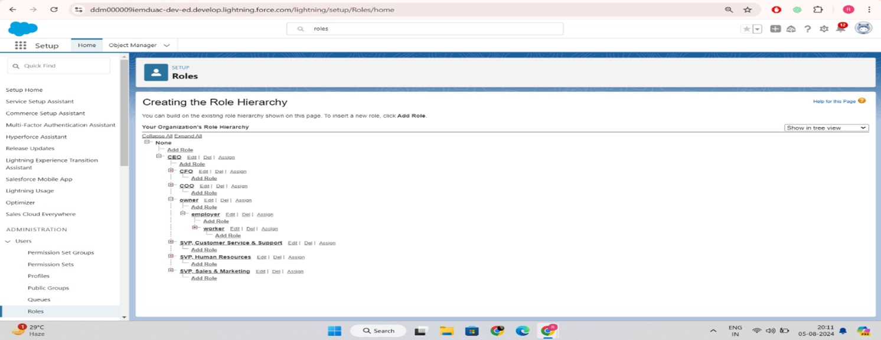

# Task 9 : Users

A user is anyone who logs in to Salesforce. Users are employees at your company, suchas sales reps, managers, and IT specialists, who need access to the company's records.Every user in Salesforce has a user account. The user account identifies the user, and theuser account settings determine what features and records the user can access.

## Create User

* + 1. Go to setup >> type users in quick find box >> select users >> click New user.
    2. Fill in the fields
    3. First Name: vicky
    4. Last Name: y
    5. Alias: Give a Alias Name
    6. Email id: Give your Personal Email id
    7. Username: Username should be in this form: [text@text.text](mailto:text@text.text)
    8. Nick Name: Give a Nickname
    9. Role: owner
    10. User license: Salesforce
    11. Profiles: owner.
    12. 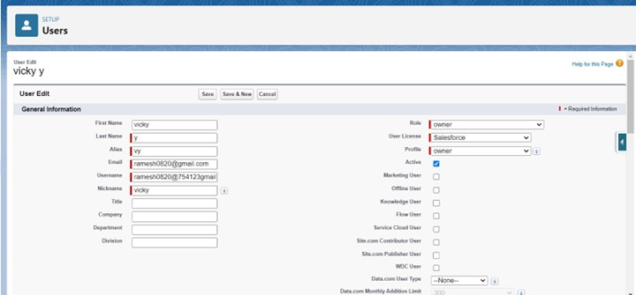Save it.

## creating another users

* + 1. Go to setup ? type users in quick find box ? select users ? click New user.
    2. Fill in the fields
    3. First Name: ram
    4. Last Name: ram
    5. Alias: Give a Alias Name
    6. Email id: Give your Personal Email id
    7. Username: Username should be in this form: [text@text.text](mailto:text@text.text)
    8. Nick Name: Give a Nickname
    9. Role: employer
    10. User license: Salesforce platform
    11. 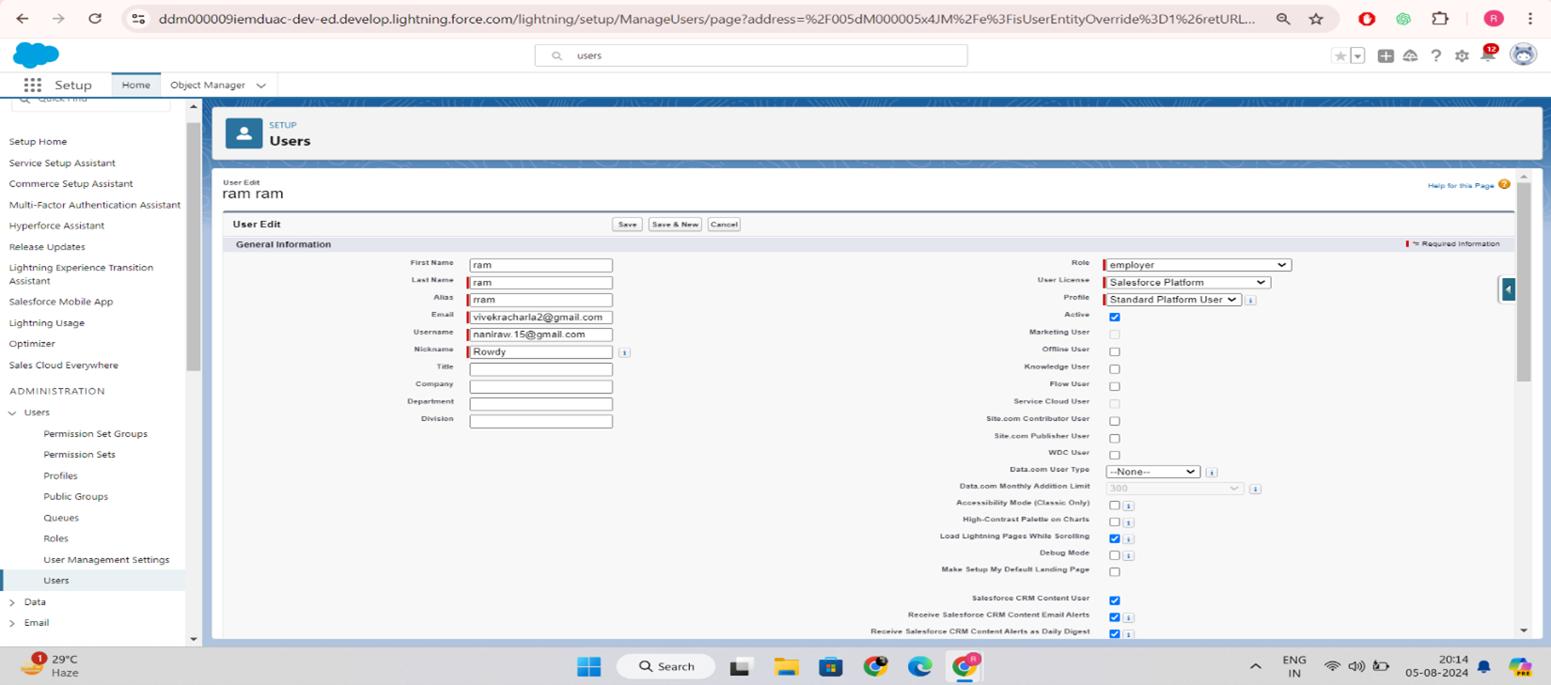Profiles: standard platform user.

## Create Another User

* + 1. Go to setup ? type users in quick find box ? select users ? click New user.
    2. Fill in the fields
    3. First Name : ragu
    4. Last Name : raj
    5. Alias : Give a Alias Name
    6. Email id : Give your Personal Email id
    7. Username : Username should be in this form: [text@text.text](mailto:text@text.text)
    8. Nick Name : Give a Nickname
    9. Role : worker
    10. User license : Salesforce platform
    11. 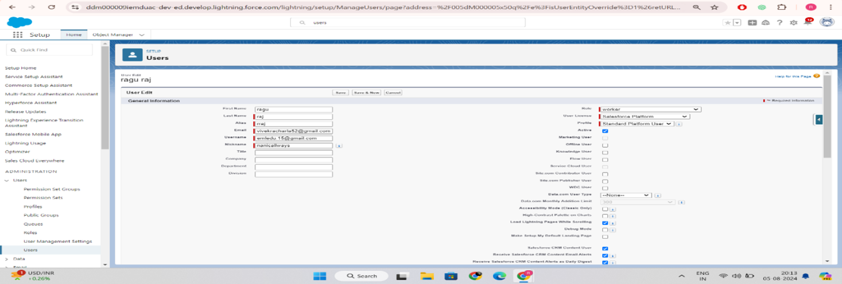Profiles : standard platform user.

# Task 10 : Permission sets

A permission set is a collection of settings and permissions that give users access to various tools and functions. Permission sets extend users’ functional access without changing their profiles and are the recommended way to manage your users’ permissions.

## Creating OWD setting.

* + 1. Go to setup >> type “sharing settings ” in quick search >> Click edit.
    2. Scroll down, change the default internal access to “ public read-only” for rice mill andsupplier object.
    3. Click save.
    4. Extra information, By these every profile has their own access, according to their profile.
    5. But in our case we created roles and given the roles in such a way that the owner can see employer and worker records , and the employer can see the worker records.

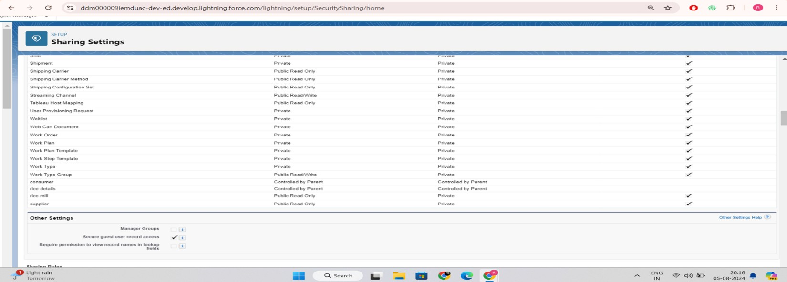

# Task 11 : Reports

Note : Before creating a report, create the latest “10” records inconsumer objects. Try to fill every field in each record for better experience.

1. Go to the app >>click on the reports tab
2. Click New Report.

select for report type, search for “rice mill with consumers” click on it. And click on start report.

Their outline pane is opened already, select the fields that are mentioned below in the column section.

1. consumer name
2. rice type
3. rice price/kg
4. mode of payments
5. amount paid
6. Remove the unnecessary fields.
7. Select the fields that are mentioned below in the GROUP ROWS section.
8. Rice taken by shops
9. Click save and run and save the report as “range of amount per day”.and save it.

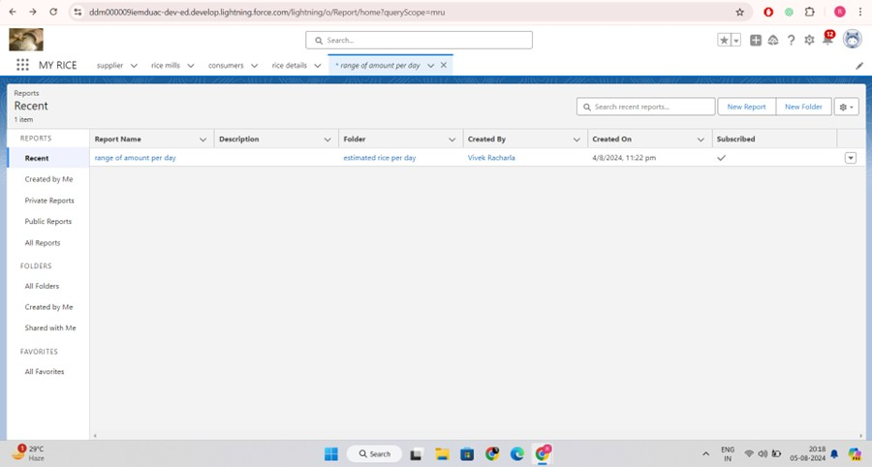

## Sharing report to owner

Click edit drop down and select subscribe option

* + 1. 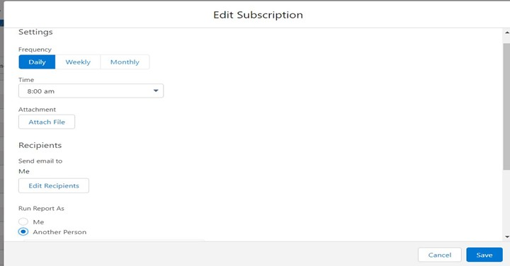Follow as per below image.

## create a report folder

1.navigate to app launcher and click reports on that. 2.click all reports.

3. Select the range of amount per day drop down in that click move.

5. Select estimated rice per day folder and select folder.

Note: if you want to see the report which you have created then go to reports - all folders - estimated rice per day - your report will appear in this way.

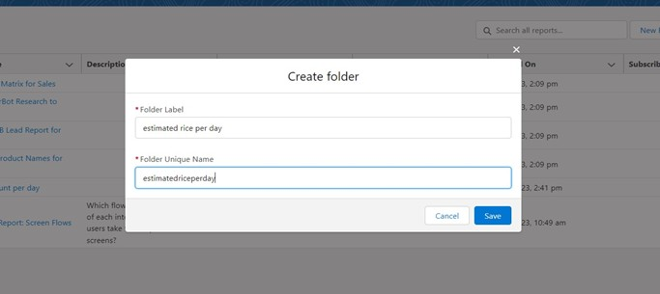

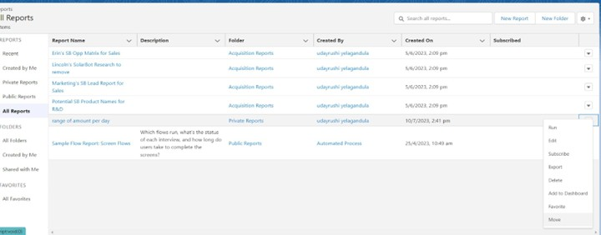

**Task 12 : Dashboards**

Dashboards help you visually understand changing business conditions so you can make decisions based on the real-time data you’ve gathered with reports. Use dashboards to help users identify trends, sort out quantities, and measure the impact of their activities. Before building, reading, and sharing dashboards, review these dashboard basics.

## Create Dashboard Folder

* + 1. Click on the app launcher and search for the dashboard.
    2. Click on the dashboard tab.
    3. Click the new folder, give the folder label as “ amount data dashboard”.
    4. Folder unique names will be auto populated.
    5. 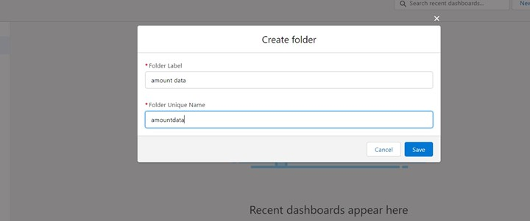Click save.

## Create Dashboard

* + 1. Go to the app >> click on the Dashboards tabs.
    2. Give a Name and select the folder that was created, and click on create.
    3. Select add component
    4. Select a Report and click on select.

Preview is shown below. Display as>> vertical bar chart X-axis >> rice taken by shops Y-axis >> sum of amount

Y-axis range >> automatic Sort by >> rice taken by shops

1. Component theme >> dark.
2. Add the component
3. Again select add component with above same steps
4. .display as donut chart
5. sort by >> sum of amount
6. .title>>range of amount per day
7. component theme dark
8. click add.
9. 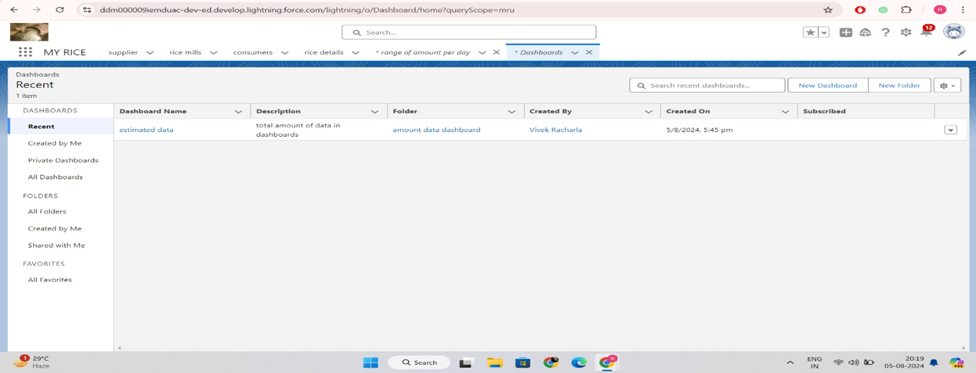Click save and done.

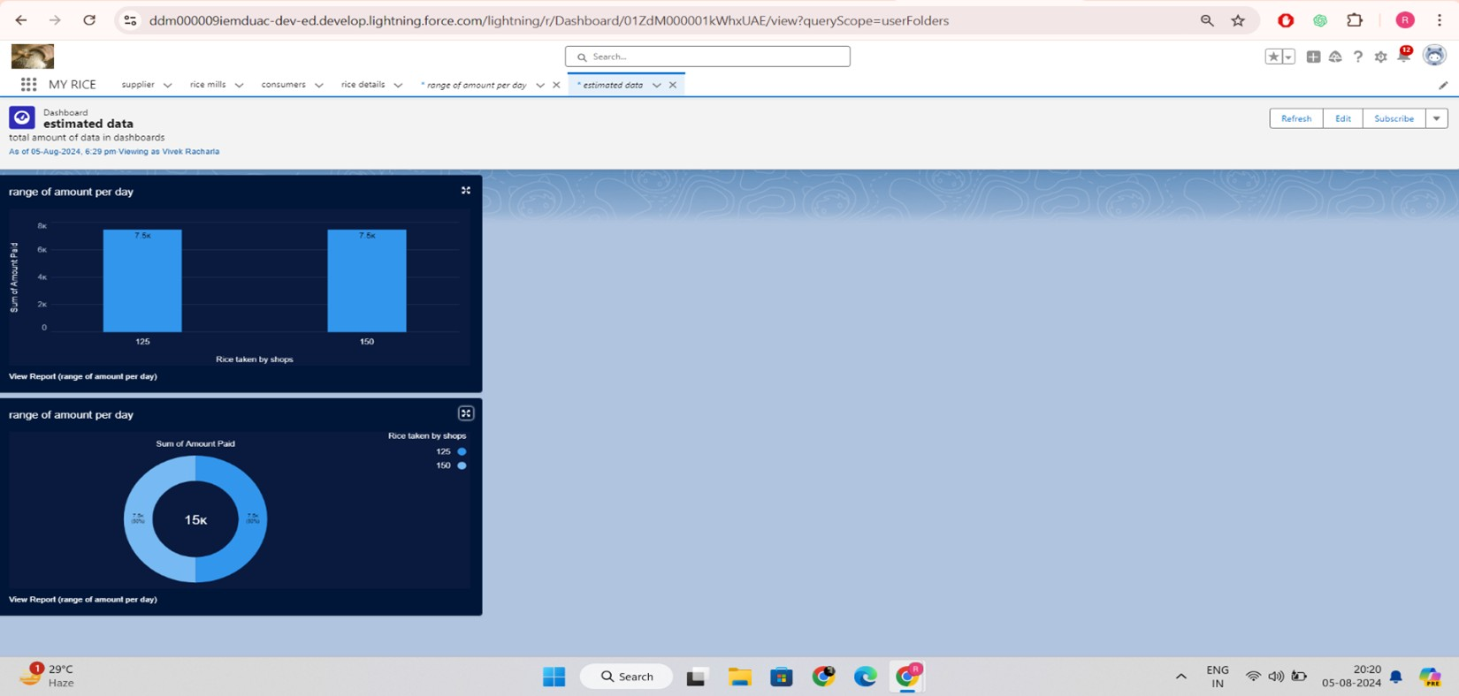

# Task 13 : Apex

Apex is a strongly typed, object-oriented programming language that allows developers to execute flow and transaction control statements on the Lightning platform server in conjunction with calls to the Lightning Platform? API. Using syntax that looks like Java and acts like database stored procedures, Apex enables developers to add business logic to most system events, including button clicks, related record updates, and Visualforce pages. Apex code can be initiated by Web service requests and from triggers on objects.

It is as similar as java i.e, it also supports OOP( Object oriented programming) like Classes, objects, methods.

### Creating Classes :

Apex classes are modeled on their counterparts in Java. You’ll define, instantiate, and extend classes, and you’ll work with interfaces, Apex class versions, properties, and other related class concepts.

### Class:

As in Java, you can create classes in Apex. A class is a template or blueprint from which objects are created. An object is an instance of a class.

### Object

Object is an instance of a class, where it can access all the properties that are present in a class i.e, variables and methods.

a. **Creating an Apex Class(ConsumerRecord)**

1. Login to the Salesforce account and navigate to the gear account in the top right corner.
2. Then we can see the Developer console. Click on the developer console and you will navigate to a new console window.
3. Then you can see many tools in the Toolbar of the new console window. Click on File, New and Apex Class.
4. Enter the name of the class(ConsumerRecord) to create a new class file.

## Code Snippet :

class ConsumerRecord {

public static void sendEmailNotification (List<consumer c> con){ for(consumer c c:con)

{

Messaging.SingleEmailMessage email = new Messaging.SingleEmailMessage();

email.setToAddresses( new List<String>{c.email c}); email.setSubject('Welcome to our company');

email.setPlainTextBody('Dear ' + ' '+ ',\n\nWelcome to MY RICE!'+'You have been seen as a valuable customer to us. PLease continue your journey with us, while we try to provide you with good quality resources.'+'\n'+

"We are proud to associate with valuable customers like you and we look forward to collaborating with you by providing more and more exciting discounts or even product offers too.' + '\n'

+'So why taking a step back, take a leap of faith and shop with us more, while we provide with the valuable products and offers'+'\n'+'\n'+'\n'+

'Thankyou for buying '+ '' +'Here are some of the products that are brought by the customers who similarly bought products like this'+'\n\n');

Messaging.sendEmail(new List<Messaging.SingleEmailMessage>{email});

}

}

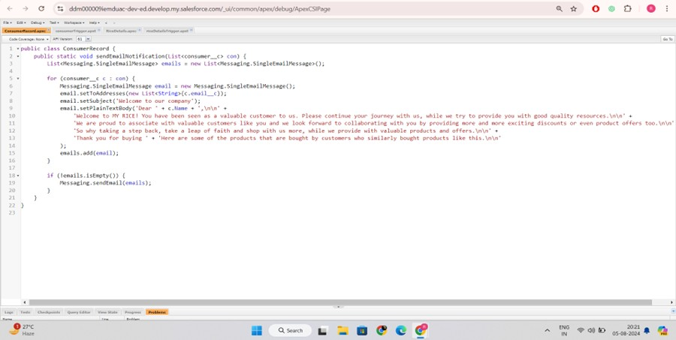}

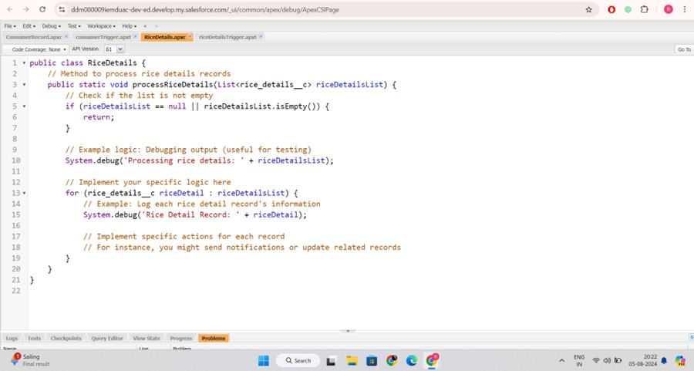

## 13.2. Creating an Apex Trigger

How to create a new trigger :

While still in the trailhead account, navigate to the gear icon in the top right corner. Click on developer console and you will be navigated to a new console window.

Click on the File menu in the toolbar, and click on new? Trigger. Enter the trigger name and the object to be triggered**.**

### Syntax For creating trigger :

The syntax for creating trigger is :

Trigger [trigger name] on [object name]( Before/After event) {

//Trigger Logic

### }

**Trigger code:**

trigger consumerTrigger on consumer c (After insert) { if(trigger.isAfter && trigger.isInsert) {

ConsumerRecord.sendEmailNotification(trigger.new);

}

}

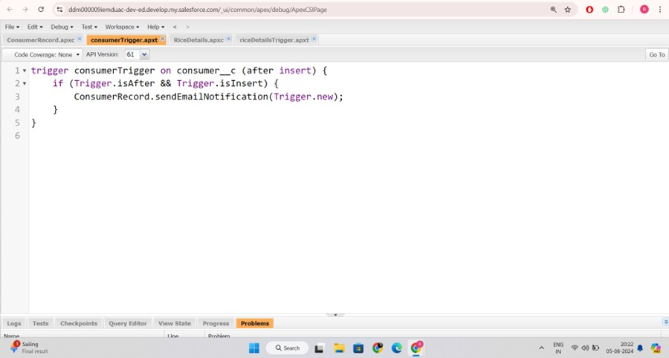

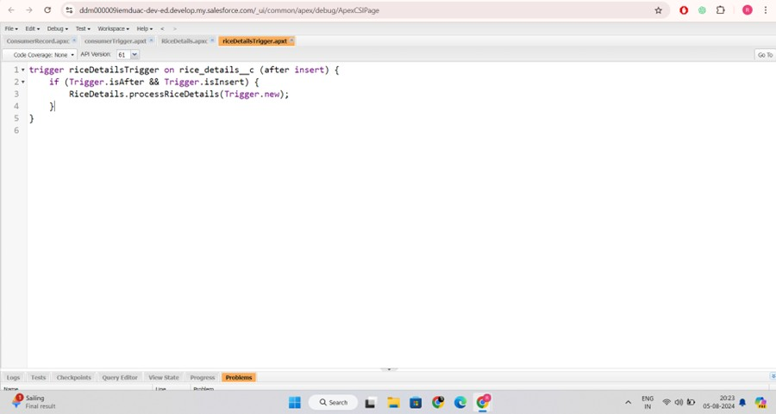

**Thank you**